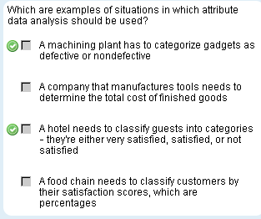

Usually we work with continuous type variables, and we apply
- Simple linear regression
- Multiple regression

But when we have attribute (discrete) data (noncontinous or composed of individual or unconnected elements like small/medium/large) then we use
- Logistic regression
- Logit analysis
- Probit analysis

1. Logistic regression
Relates one or more independent variables to an attribute dependent values of interest, such as yes or no, pass or fail, or nominal or ordinal categories.

2. Logit analysis
When you want to determine how much more likely an observation is to be a member of one category instead of another category

3. Probit analysis
Is comparable to accelerated life testing and survivability analysis. You impose a stress on an item and determine if it fails or survives.

1. LOGISTIC ANALYSIS

Similarities between linear regression and logistic regression

- Both investigate relationship betwen variables, (one dependent variable against one or more independent variables)
- Both predict responses values from desire of independent values

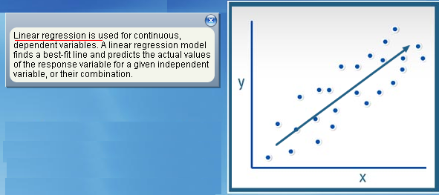

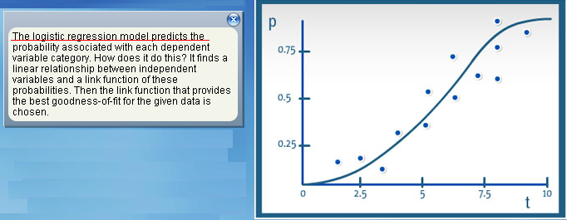

Type of logistic regression
- Simple (one independent variable)
- Multiple (multiple independent variable)

Here is the formula for multiple linear regression, there are many coefficients
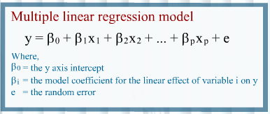

You can determine the probability of result been in a category by using this formula

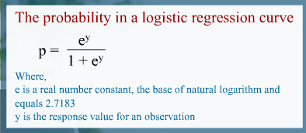

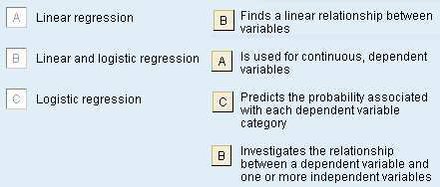

There are 3 method for a logistic regression depending of the type of attribute data
- Binary: 2 outcomes (Fail / Pass or Presence / absence of disease )
- Nominal: More than 2 outcomes with no ordering ( blue, red, white )
- Ordinal: More than 2 outcomes with ordering (small / medium / large )

Logistic regression assumptions
- Out outcome per event (Yes or No / Small or Medium or Large )
- Outcomes are statistically independent
- Relevant predictors are in the model
- One category at a time
- Sample sizes larger than linear regression

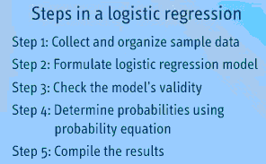

Step 1: During the first step
- You identify 55 circuits with errors, and determine whether those errors were detected by inspections
- Errors detected are labeled as 1, and those not detected are labeled 0
- Time spent on inspection (in minutes) for each observation is also noted

Obs. | Inspection time | Error detection  Yes = 1  No = 0 |  | Obs. | Inspection time | Error detection  Yes = 1  No = 0 |  | Obs. | Inspection time | Error detection  Yes = 1  No = 0
1 | 38 | 1 |  | 20 | 39 | 1 |  | 38 | 22 | 0
2 | 29 | 0 |  | 21 | 30 | 0 |  | 39 | 18 | 0
3 | 34 | 0 |  | 22 | 37 | 1 |  | 40 | 22 | 0
4 | 35 | 1 |  | 23 | 41 | 1 |  | 41 | 40 | 1
5 | 32 | 1 |  | 24 | 23 | 0 |  | 42 | 37 | 1
6 | 41 | 1 |  | 25 | 18 | 0 |  | 43 | 41 | 1
7 | 35 | 0 |  | 26 | 22 | 0 |  | 44 | 30 | 1
8 | 41 | 1 |  | 27 | 23 | 0 |  | 45 | 23 | 0
9 | 24 | 0 |  | 28 | 20 | 0 |  | 46 | 19 | 0
10 | 28 | 1 |  | 29 | 27 | 0 |  | 47 | 21 | 0
11 | 32 | 0 |  | 30 | 30 | 1 |  | 48 | 21 | 0
12 | 36 | 1 |  | 31 | 34 | 1 |  | 49 | 29 | 1
13 | 20 | 0 |  | 32 | 31 | 0 |  | 50 | 32 | 1
14 | 21 | 0 |  | 33 | 28 | 0 |  | 51 | 21 | 0
15 | 39 | 1 |  | 34 | 21 | 0 |  | 52 | 29 | 1
16 | 42 | 1 |  | 35 | 21 | 0 |  | 53 | 31 | 0
17 | 27 | 0 |  | 36 | 38 | 1 |  | 54 | 40 | 1
18 | 20 | 1 |  | 37 | 40 | 1 |  | 55 | 37 | 1
19 | 37 | 1

Step 2: Formulate the logistic regression model

Y = -9.94645 + 0.328827 X

Dependent variable: If error detected (Y)
Independent variable: Time for observation (X)

Step 3: Check the model’s validity

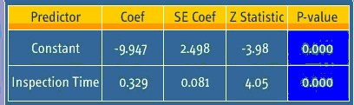

The important is the P-value is zero, lower then 0.05 the alpha value.
It means there is a significant relationship between variables

Second validation is the goodness for fit

Chi-square statistic 7.6831
Degree of freedom: 20
p-value 0.608 (the model fit the equation

Then you use the probability equation to calculate probabilities for all 55 observations. (Column probability)

Step 4: Determine probability

Using the fitness line: Y = -9.94645 + 0.328827 X

For value X = 40 then Y = 3.20663

Then we calculate the probability with the following formula

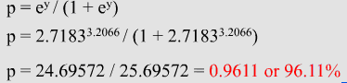

This mean: Inspections that take 40 minutes have 96.11% probability to DETECT the error

Calculating the probability in each observation give us the following table

Obs. | Inspection time | Probability |  | Obs. | Inspection time | Probability |  | Obs. | Inspection time | Probability
1 | 38 | 0.928 |  | 20 | 39 | 0.947 |  | 38 | 22 | 0.062
2 | 29 | 0.399 |  | 21 | 30 | 0.48 |  | 39 | 18 | 0.018
3 | 34 | 0.774 |  | 22 | 37 | 0.902 |  | 40 | 22 | 0.062
4 | 35 | 0.827 |  | 23 | 41 | 0.972 |  | 41 | 40 | 0.961
5 | 32 | 0.64 |  | 24 | 23 | 0.084 |  | 42 | 37 | 0.902
6 | 41 | 0.972 |  | 25 | 18 | 0.018 |  | 43 | 41 | 0.972
7 | 35 | 0.827 |  | 26 | 22 | 0.062 |  | 44 | 30 | 0.48
8 | 41 | 0.972 |  | 27 | 23 | 0.084 |  | 45 | 23 | 0.084
9 | 24 | 0.114 |  | 28 | 20 | 0.033 |  | 46 | 19 | 0.024
10 | 28 | 0.323 |  | 29 | 27 | 0.256 |  | 47 | 21 | 0.046
11 | 32 | 0.64 |  | 30 | 30 | 0.48 |  | 48 | 21 | 0.046
12 | 36 | 0.869 |  | 31 | 34 | 0.774 |  | 49 | 29 | 0.399
13 | 20 | 0.033 |  | 32 | 31 | 0.561 |  | 50 | 32 | 0.64
14 | 21 | 0.046 |  | 33 | 28 | 0.323 |  | 51 | 21 | 0.046
15 | 39 | 0.947 |  | 34 | 21 | 0.046 |  | 52 | 29 | 0.399
16 | 42 | 0.979 |  | 35 | 21 | 0.046 |  | 53 | 31 | 0.561
17 | 27 | 0.256 |  | 36 | 38 | 0.928 |  | 54 | 40 | 0.961
18 | 20 | 0.033 |  | 37 | 40 | 0.961 |  | 55 | 37 | 0.902
19 | 37 | 0.902

Step 5: Compile results
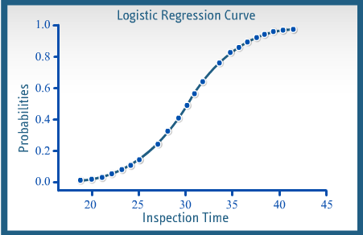

Summarize
Attribute data is noncontinuous, which means it’s composed of individual or unconnected elements. You can use 3 techniques to analyze attribute data: logistic regression, logit analysis, probit analysis

Depending on the nature of the data, you can use 3 methods for performing logistic regression: binary, nominal, and ordinal

Logit and probit analysis

Logit and probit analysis help estimate maximum likelihood of an event's occurrence or non-occurence, by predicting an attribute dependent variable from one or more independent variables.

The dependent variables - y- is attribute, or discrete, and represent a bynary choice or a category

Samples to use logit or probit analysis
- What type of consumer buys a specific type of vehicle.
- What causes a customer to choose one type of vehicle.
- Study the impact for each selection choice

Logit and probit assumptions
- Observations on y have been randomly sample
- Y caused by x's
- Relationship between y and x's is uncertain
- Assess distribution error

Differences between Logit and Probit analysis
- Logit model has flatter tails
- Both provide population parameter estimates which may differ

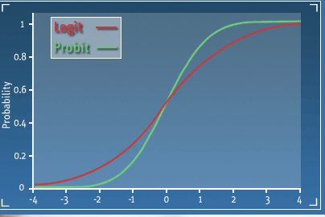
LOGIT ANALYSIS

Logit analysis
- Produces results that are statistically sound.
- It helps you avoid out-of-range estimates by transforming a dichotomous dependent variable into a continuous variable ranging in value from negative infinity to positive infinity
- Its results are easily interpreted, plus the method is easy to analyze
- It allows to apply the analog of the regression t-test by giving parameter estimates that are efficient and asymptotically consistent
- It uses odds to determine how much more likely is that an observation will be in one category (pass or fail for instance)

Using odds:
A probability of p=0.80 of being in group A (passing) can be expressed in odds terms as 4 to 1.
There are 4 chances to pass vrs 1 chance to fail

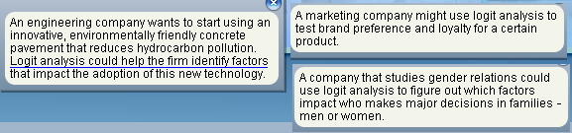

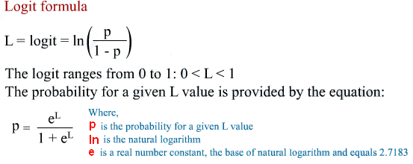

Once you know the probability P you calculate the odds Odds = P / ( 1 - P )

Example
Obs. | Inspection time | Error detection  Yes = 1  No = 0 |  | Obs. | Inspection time | Error detection  Yes = 1  No = 0 |  | Obs. | Inspection time | Error detection  Yes = 1  No = 0
1 | 38 | 1 |  | 20 | 39 | 1 |  | 38 | 22 | 0
2 | 29 | 0 |  | 21 | 30 | 0 |  | 39 | 18 | 0
3 | 34 | 0 |  | 22 | 37 | 1 |  | 40 | 22 | 0
4 | 35 | 1 |  | 23 | 41 | 1 |  | 41 | 40 | 1
5 | 32 | 1 |  | 24 | 23 | 0 |  | 42 | 37 | 1
6 | 41 | 1 |  | 25 | 18 | 0 |  | 43 | 41 | 1
7 | 35 | 0 |  | 26 | 22 | 0 |  | 44 | 30 | 1
8 | 41 | 1 |  | 27 | 23 | 0 |  | 45 | 23 | 0
9 | 24 | 0 |  | 28 | 20 | 0 |  | 46 | 19 | 0
10 | 28 | 1 |  | 29 | 27 | 0 |  | 47 | 21 | 0
11 | 32 | 0 |  | 30 | 30 | 1 |  | 48 | 21 | 0
12 | 36 | 1 |  | 31 | 34 | 1 |  | 49 | 29 | 1
13 | 20 | 0 |  | 32 | 31 | 0 |  | 50 | 32 | 1
14 | 21 | 0 |  | 33 | 28 | 0 |  | 51 | 21 | 0
15 | 39 | 1 |  | 34 | 21 | 0 |  | 52 | 29 | 1
16 | 42 | 1 |  | 35 | 21 | 0 |  | 53 | 31 | 0
17 | 27 | 0 |  | 36 | 38 | 1 |  | 54 | 40 | 1
18 | 20 | 1 |  | 37 | 40 | 1 |  | 55 | 37 | 1
19 | 37 | 1

There are 55 observations with errors and there was detected 27 errors
The probability of a correct detection is 27 / 55 = 0.491

Odds = P / ( 1 – P ) = 0.491 / ( 1 – 0.491) = 0.965 or 0.965 : 1
This means the odds are 0.965 to 1 that defects will be correctly detected.

Imagine that you know there is a 96.11% chance the error will be detected if QA spends 40 minutes during inspection.

The odds are 0.9611 / ( 1 - 0.9611 ) = 24.71 : 1

Then
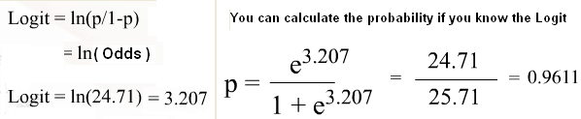

PROBIT ANALYSIS

Probit Analysis
- It is a specialized regression model used with binomial dependent variables.
- It employs a probit link function.
- It is very similar to logit, but uses cumulative normal probability distribution and is preferred with data are normaly distributed.
- It transforms the sigmoid regression curve to a straight line that can be analyzed by regression using either least squares or maximum likelihood methods.
- Often used in reliability study involving destructive testing.

The probit model is a linear function y = mx +c.
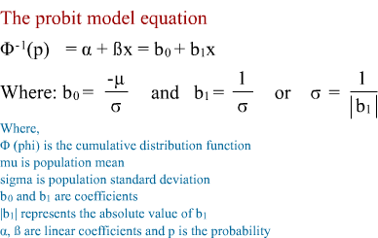

Common statistical software include 3 probit analysis outputs
- Goodness-of-fit: assesses whether an assumed distribution fits the data adequately
- Probability plot: The closer the points fall to the fitted line the better
- Table of percentiles: Shows what percentage of an event takes place at what level

A fitted probability plot can also tell for a given event, the probability of success or failure

SAMPLE
Imaging you are validating the product's capability of sustaining stress during transportation,
- Conduct a number of destructive tests and collect samples.
- Set the pressure machine at various pressure level and record the breaking response - binary data
- The test is considered a success if a product doesn't break
- Label 1 for success, label 0 for failure

You testes 5 pressures ( 10, 20, 30, 40, 50) and collect the results

Pressure (N /m2) | Result | Frequency
10 | 1 | 45
10 | 0 | 5
20 | 1 | 38
20 | 0 | 12
30 | 1 | 30
30 | 0 | 20
40 | 1 | 20
40 | 0 | 30
50 | 1 | 10
50 | 0 | 40

Bo = 3.84018 B1= -1.22776

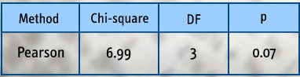

Your goodness-of-fit test again, performed using statistical software, uses Weibull distribution and determines that the p-value is 0.07, which is greater that the alpha value of 0.05. This is not a significant result and your null hypothesis that there is no difference between the observed and predicted likelihoods holds and you conclude that the Probit model fits the data.

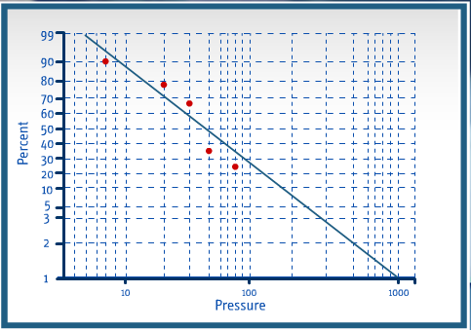

The probability plot suggest the points fit adequately because they are close to the line
Percentile table

For instance,
- At 142.69 Newton per square meter pressure, the table shows 10% of the product survive
- 50% of the product survive with a pressure of 30.76 Newton per square meter

Percent (Binary response) | Percentile (Continuous input)
1 | 967.358
2 | 547.785
3 | 392.084
4 | 308.884
5 | 256.463
6 | 220.130
7 | 193.322
8 | 172.647
9 | 156.168
10 | 142.693
20 | 77.4379
30 | 52.8508
40 | 39.4449
50 | 30.7629
60 | 24.5078
70 | 19.6209
80 | 15.4898
90 | 11.5707
91 | 11.1566
92 | 10.7310
93 | 10.2901
94 | 9.82845
95 | 9.33843
96 | 8.80767
97 | 8.21449
98 | 7.51408
99 | 6.57921
95.0% CI
SAMPLE 2
The quality and design team at a small electric motor manufacturer wants to validate the motor's capability of sustaining high voltage fluctuations. The team conducts a number of destructive tests and collects samples. All motors are connected to a current at varying voltage levels (120, 130, 140, 150, 160) for ten minutes. The failing response is recorded as binary data consisting of success (1) if the motor survives and (0) if the motor fails. A total of 100 samples were tested at each voltage level. The results are displayed in this table:
Motor manufacturer samples
Voltage | Response | Frequency
120 | 1 | 94
120 | 0 | 6
130 | 1 | 82
130 | 0 | 18
140 | 1 | 77
140 | 0 | 23
150 | 1 | 62
150 | 0 | 38
160 | 1 | 48
160 | 0 | 52
Distribution: Weibull
Using statistical software, the coefficients are found as b0 = 23.97, b1 = -4.79
The goodness-of-fit test p values
Method | Chi-square | Df | p
Pearson | 1.52580 | 3 | 0.676

With alpha value of 0.05 then the p value is insignificant , higher than alpha, keep going
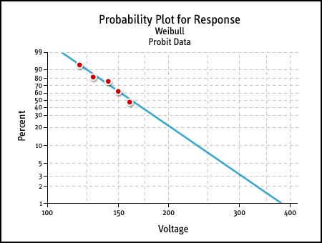

From the probability plot: Model fits data adequately, points close to line

Table of Percentiles (Partial)
Percent | Percentile | Std. Error | Lower | Upper
1 | 387.132 | 50.6483 | 315.204 | 544.452
2 | 334.665 | 37.6267 | 280.456 | 448.573
3 | 307.197 | 31.2200 | 261.832 | 400.292
4 | 288.995 | 27.1465 | 249.304 | 369.073
5 | 275.553 | 24.2327 | 239.949 | 346.435
10 | 237.136 | 16.3901 | 212.667 | 283.799
20 | 202.777 | 10.0756 | 187.450 | 230.615
30 | 183.879 | 6.94756 | 173.150 | 202.659
40 | 170.605 | 4.94114 | 162.845 | 183.670
50 | 160.082 | 3.51031 | 154.430 | 169.095

From the percentile table: There is a 50% change of survival at 160.082 volts

SAMPLE 3
The product manager at a large auto parts manufacturer wants to conduct a survivability analysis of its latest model windshields. A crash test is conducted at the company's testing range and data samples are collected. A mechanical device mounts the windshields, runs a 100 m runway at varying velocity levels (120, 150, 180, 200, 220, 250, and 280), and crashes into an iron wall. The breakage response is recorded as binary data consisting of success (1 - does not break/survives) or failure (0 - breaks/fails). A total of 20 samples were tested at each velocity level. The results are displayed in this table:
Auto parts manufacturer samples
Velocity | Response | Frequency
120 | 1 | 19
120 | 0 | 1
150 | 1 | 18
150 | 0 | 2
180 | 1 | 16
180 | 0 | 4
200 | 1 | 17
200 | 0 | 3
220 | 1 | 15
220 | 0 | 5
250 | 1 | 12
250 | 0 | 8
280 | 1 | 19
280 | 0 | 1
Distribution: Weibull
Using statistical software, the coefficients are found as b0 = 15.21, b1 = -2.86
The goodness-of-fit test p values
Method | Chi-square | df | p
Pearson | 17.347 | 5 | 0.004

With alpha value of 0.05 then the p value is significant , higher than alpha, DON’T KEEP GOING

Probability Plot for Result
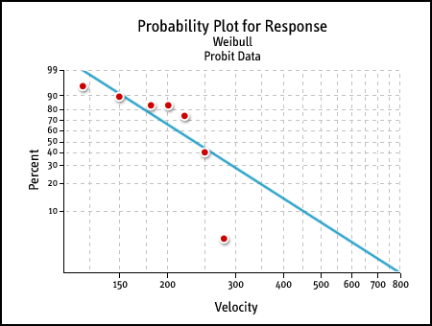

From the probability plot: Model DOESN’T fits data adequately, THERE IS AN OUTLIER

Summarize

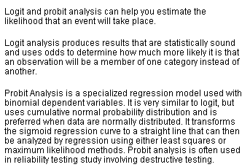

7217-1028

2257-4908

